|  |  |  |  |  |  |  |
| --- | --- | --- | --- | --- | --- | --- |
| 1 Communion  Carols & Choirs at Scottsburg 1st Baptist,  6 PM | 2 | 3 | 4  High School Small Group Mtg. at Pastor Tyler’s, 3P | 5 | 6  Craft Night in FLC Angie Avendano, 6 | 7  FLC in use, 1-3 pm  Bethlehem Lights at SEBYCamp,  5-8 PM (4:12 Youth work it)  Rita Fields |
| 8  Deacon’s Mtg.  12 PM  Lunch with Santa in FLC, 12-1 PM  chi | 9  CCA Pastors Mtg. at Denny’s, 1 pm | 10 | 11  Business Mtg. 6:30 | 12 | 13  Mrs. Claus Kitchen  In FLC, 6 PM  McDonald girls in charge  (Judy off work) | 14 |
| 15  Trustees mtg.11:45  4:12 Youth going Christmas Caroling  12-5 PM  FLC in use, 1-4 PM | 16 | 17 January Right-Click on the filename below to download this image and choose "Save Target As" or "Save Link As" | 18  HS Small Group Mtg.  at Pastor Tyler’s, 3pm  “Happy Birthday Jesus” Party in FLC  6-7:30 PM | 19 | 20  (Judy off work) | 21winter_27645c  Youth Bell ringing at Wal-Mart, 10am-12p  Shared Blessings  10 a.m.-2 PM |
| 22 | 23  Schools on Christmas Break thru Jan. 3rd | 24  FLC in use, 5-9 PM  McDonald Family  Christmas Eve  Service, 11 PM | 25  candle_29289ac | 26 | 27 | 28 |
| 29  Outing to Derby Dinner, 6 PM  to see “A Wonderful Life” | 30 | 31  4:12 Youth  Lock-in  5 PM-9 a.m. |  |  |  |  |
|  |  |  |  |  |  |  |

**KIMBERLIN CREEK BAPTIST CHURCH**

**Regular Weekly Schedule**

Sunday 9:30 a.m. Sunday School

10:30 a.m. Morning Worship

Wednesday

5:30 p.m. Family Meal

6:30 p.m. Adult Bible Study

4:12 Youth

Kingdom Kids

**Morning Worship Greeters**

December 1 Susan Kloke/Pat McNeely

December 8 Larry & Carol Fletcher

December 15 Dixie Miller/Barb Deal

December 22 4:12 Youth

December 29 JoAn Azure/Becky Scott

\*\*\*\*\*\*\*\*\*\*\*\*\*\*\*\*\*\*\*\*\*\*\*\*\*\*\*\*\*\*\*

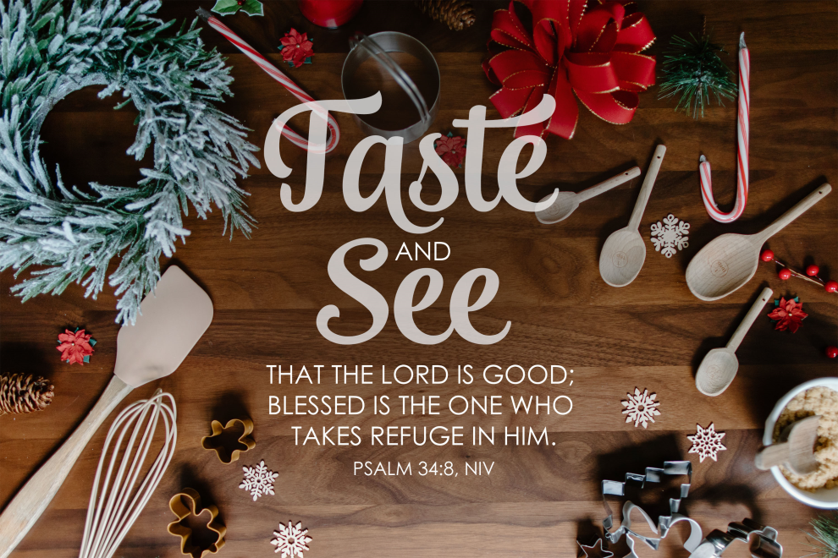

**Wednesday Night Family Meals**

**December 4: Sausage Gravy**

prepared by: Rita Fields

Side dishes for you to bring:

Biscuits, Butter, Jelly, Hashbrowns, Scrambled Eggs, Fruit, Milk, Juice

**December 11: Cold Cut Subs**

prepared by: Malina Jeffries

Side dishes for you to bring:

French Fries, Onion Rings, Cole Slaw, Potato & Tossed Salad, Fruit, Desserts

**December 18:**

at “Happy Birthday Jesus” Party

Side dishes for you to bring:

Fruit, Desserts

**December 25: Christmas Day**

No meal or services

prepared by

Side dishes for you to bring:

, Desserts

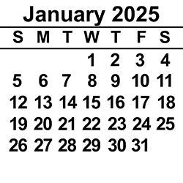

Deacon of the Week Children’s Worship

Dec. 1 Stephen Spicer Family Sunday

Dec. 8 Chris Beverly Rita Fields/Angie Avendaño

Dec. 15 Larry Blevins Rita Fields/Angie Avendaño

Dec. 22 Jeff Riley Rita Fields/Angie Avendaño

Dec. 29 Stephen Spicer Rita Fields/Angie Avendaño

DECEMBER 2024

**Sunday Monday Tuesday Wednesday Thursday Friday Saturday**

SUN MON TUE WED THUR FRI SAT

ABY FALL RETREAT at Camp Camby, November 7th-9th

**VACATION BIBLE SCHOOL NIGHTLY BEGINNING WITH A MEAL AT 5:30 PM & ENDING AT 8:30 PM.**

Kindergarten Camp 3 PM Sun.-4 PM Mon.

Women’s Conference at KCBC for all women of the church & the community. Led by Jenny Beverly.

2012

|  |  |
| --- | --- |
|  | 21  5:00 PM Friday thru 4:00 PM on Saturday |