 |  |  |  |  | 1  Kingdom Kids Yard Sale in FLC,  8 a.m.-5 PM | 2  Kingdom Kids Yard Sale in FLC,  8 a.m.-2 PM
3 Communion  Deacon’s Mtg. 12 PM  CCA Board Mtg. 2 PM  Bd. Christian Ministry Mtg. 3:30 PM  Youth Gathering, 5P  Youth  chi | 4  Pastor Tim will be on vacation 4-11 | 5 | 6 | 7 | 8 | 9
10 | 11 | 12 | 13  Business Mtg. 6:30 | 14  Church Secretary, Judy Peacock is out of the office | 15  Church Secretary, Judy Peacock is out of the office | 16  Shared Blessings  10 a.m.-2 PM
17  “Show the Love” Clean-up Hwy. 356 12-2:30 PM  Youth Gathering  2:30-5:00 PM | 18 | 19 November | 20 | 21  Flu Shot Clinic KCBC, 4-7 PM  Call the church for an appt. | 22 | 23  Soup Supper & Hayride, 6-9 PM
24  31 | 25 | 26 | 27 | 28  Youth Fundraiser at Texas Roadhouse. Mention KCBC Youth & they receive 10 % of the cost of your meal. | 29 | 30  Kingdom Kids  Craft Sale at KCBC,  10 a.m.-?  Youth Party at Hardy Lake Campground.  3-10 PM
- 2021
Deacon of the Week MW Nursery Children’s Worship

Oct. 3 Chris Beverly Family Sunday

Oct. 10 Larry Blevins Rita Fields/Angie Avendaño

Oct. 17 Doug Gross Rita Fields/Angie Avendaño

Oct. 24 Jeff Riley Rita Fields/Angie Avendaño

Oct. 31 Stephen Spicer Rita Fields/Angie Avendaño

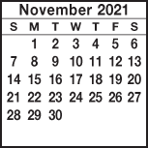
KIMBERLIN CREEK BAPTIST CHURCH
Regular Weekly Schedule

Sunday 9:30 a.m. Sunday School
10:30 a.m. Morning Worship
Tuesday 6:30 p.m. Choir Practice
Wednesday
6:30 p.m. Adult Bible Study
Kingdom Kids
4:12 Youth

Morning Worship Greeters

Oct. 3 JoAn Azure/Becky Scott
Oct. 10 Rita Fields/Angie Avendaño
Oct. 17 Susan Kloke/Pat McNeely
Oct. 24 4:12 Youth
Oct. 31 Larry & Marcia Blevins
*******************************
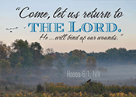

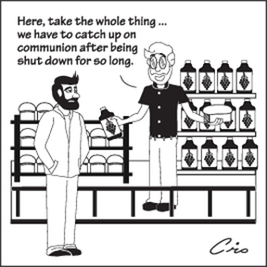

Sunday Monday Tuesday Wednesday Thursday Friday Saturday
SUN MON TUE WED THUR FRI SAT
ABY FALL RETREAT at Camp Camby, November 7th-9th
VACATION BIBLE SCHOOL NIGHTLY BEGINNING WITH A MEAL AT 5:30 PM & ENDING AT 8:30 PM.
Kindergarten Camp 3 PM Sun.-4 PM Mon.

Women’s Conference at KCBC for all women of the church & the community. Led by Jenny Beverly.
2012

21

5:00 PM Friday thru 4:00 PM on Saturday

