1  Youth Outing to Clifty Falls State Park, 12-7 PM | 2 | 3 | 4 | 5 | 6 | 7  The Race at SEBYC, 8 a.m.- 12  CCA ABMen’s Family Picnic @ ??, 4 PM
8 Communion  Deacon’s Mtg. 12  Back to School Bash 2-5 PM  chi | 9 | 10  Red Cross Blood Drive in FLC  3-8 PM | 11  Annual  Business Mtg. 6:30 | 12 | 13 | 14
15  Youth leaving after church to go see Casting Crowns at the Indiana State Fair in Indianapolis | 16 | 17 | 18 | 19 | 20 | 21  Shared Blessings 10 a.m.-2 PM  FLC in use, 3:30-9  Stainbrook family
22  Youth Spaghetti Dinner 12-1:30 PM | 23  Youth leaving around 3:30 PM to see Zach Williams at the Kentucky State Fair in Louisville | 24 September | 25  Year-end Bash at Bobby & Barb Deal’s, 6-8 PM  (for all ages) | 26 | 27 | 28  Church Fall Clean-up Day  8 a.m.-Noon ?
29 | 30 | 31
We will begin having the nursery available again in September. If you would like to be a nursery worker, please see Diana Sebastian or call her at 812-595-2253 as soon as possible so a schedule can be made before September 1st.
dke.
AUGUST 2021
Deacon of the Week MW Nursery Children’s Worship

August 1 Doug Gross Family Sunday

August 8 Pastor Tyler Griffin Rita Fields & Angie Avendaño

August 15 Jeff Riley Rita Fields & Angie Avendaño

August 22 Stephen Spicer Rita Fields & Angie Avendaño

August 29 Chris Beverly Rita Fields & Angie Avendaño
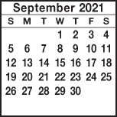
KIMBERLIN CREEK BAPTIST CHURCH
Regular Weekly Schedule

Sunday 9:30 a.m. Sunday School
10:30 a.m. Morning Worship
Wednesday
6:30 p.m. Adult Bible Study
Kingdom Kids
4:12 Youth

Morning Worship Greeters

Aug. 1 Rob & Michelle Gary
Aug. 8 JoAn Azure/Becky Scott
Aug. 15 Rita Fields/Angie Avendaño
Aug. 22 The Youth
Aug. 29 Larry & Marcia Blevins
*******************************
Sunday Mornings at 9:30 a.m. Classes for Children, Youth and Adults. At 9:20 a.m. the deacons are providing
snacks, coffee, milk & juice.

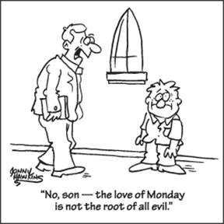

Sunday Monday Tuesday Wednesday Thursday Friday Saturday
SUN MON TUE WED THUR FRI SAT
ABY FALL RETREAT at Camp Camby, November 7th-9th
VACATION BIBLE SCHOOL NIGHTLY BEGINNING WITH A MEAL AT 5:30 PM & ENDING AT 8:30 PM.
Kindergarten Camp 3 PM Sun.-4 PM Mon.

Women’s Conference at KCBC for all women of the church & the community. Led by Jenny Beverly.
2012

21

5:00 PM Friday thru 4:00 PM on Saturday

