 |  |  |  | 1 | 2 | 3
4 Communion  Deacon’s Mtg. 12  Scott County Fair  4th-10th  chi | 5  Church Office Closed | 6 | 7  No Services due to the Fair. | 8 | 9-10 ABWM  Summer Conf. at St. Joseph Conf. & Retreat Ctr. in Tipton, IN | 10  You are invited to the 50th Wedding Anniversary for Danny & Kathy Snelling in the Family Life Center,  2-5 PM
11  Deacon’s Mtg., 12 PM  CCA Exec. Bd. mtg, 2  Bd. of Chr. Min. mtg.,  3:30 PM  Junior Camp, 11-16 | 12 | 13 | 14  Business Mtg. 6:30 | 15 | 16 August | 17  Shared Blessings, 10 a.m.-2 PM
18 | 19  “ROCKY RAILWAY”, VACATION BIBLE SCHOOL, 5:30-5:50 PM meal; Classes, 6-8:30 PM | 20  Louisville Bats game  Leave church at 9:30 a.m. | 21 | 22 | 23 | 24
25 VBS Program  Primary Camp,  25th-28th  FLC in use, Romero Family, 1-5 PM | 26  Pastor Tim will be on vacation from July 26-August 2 | 27 | 28 | 29 | 30 | 31
JULY 2021
Deacon of the Week MW Nursery Children’s Worship

July 4 Doug Gross None Family Sunday

July 11 Pastor Tyler None Rita Fields/Angie Avendano

July 18 Stephen Spicer None Rita Fields/Angie Avendano

July 25 Chris Beverly None None- VBS program

Apr. 30 Cliff Fee Amanda Hurt Leah Griffin/Maria Gary Jessica Craig

KIMBERLIN CREEK BAPTIST CHURCH
Regular Weekly Schedule

Sunday 9:30 a.m. Sunday School
10:30 a.m. Morning Worship
Wednesday
6:30 p.m. Adult Bible Study
Kingdom Kidds
4:12 Youth

Sunday School Greeters

Morning Worship Greeters

*******************************

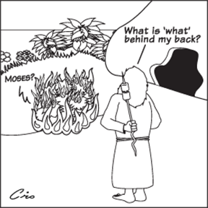

Sunday Monday Tuesday Wednesday Thursday Friday Saturday
SUN MON TUE WED THUR FRI SAT
ABY FALL RETREAT at Camp Camby, November 7th-9th
VACATION BIBLE SCHOOL NIGHTLY BEGINNING WITH A MEAL AT 5:30 PM & ENDING AT 8:30 PM.
Kindergarten Camp 3 PM Sun.-4 PM Mon.

Women’s Conference at KCBC for all women of the church & the community. Led by Jenny Beverly.
2012

21

5:00 PM Friday thru 4:00 PM on Saturday

