The name of the Easter cantata the choir is performing  this year is  “Living Hope”. |  |  |  | 1  Maundy Thurs. Service at Lex. Presbyterian Church, 7 PM | 2  Good Friday Service at KCBC  7:00 PM | 3  Choir Practice, 9-11
4 Communion  SONrise Service, 7 am  Breakfast in FLC, 8 am  Sunday School, 9:30  Morning Worship: Easter Cantata, 10:30  chi | 5 | 6  Red Cross Blood Drive in FLC,  3-8 PM | 7  Wednesday Services begin again at 6:30.  No Family Meal. | 8 | 9 | 10
11  Deacon’s Mtg. 12  CCA Bd. Mtg. 2 PM  Bd. of Christian Ministry Mtg., 3:30  Lunch with Santa in FLC, 12-1:30 PM | 12 | 13 | 14  Business Mtg. 6:30 PM | 15 | 16 April | 17  “Shared Blessings” 10a.m.-2pm
18  Youth Gathering  5-7 PM | 19-25  Pastor Tim & Pam will be on vacation. | 20 | 21 | 22 | 23  Women’s Retreat at Southeastern Baptist Youth Camp, 5 PM-1:30 PM | 24  Hardy Lake Sweep Youth, 9a-1P
25 | 26 | 27 | 28 | 29 | 30
KIMBERLIN CREEK BAPTIST CHURCH
Regular Weekly Schedule

Sunday 9:30 a.m. Sunday School
10:30 a.m. Morning Worship
Wednesday
6:30 p.m. Bible Study
TeamKid
Youth Meeting

Sunday School Greeters

Morning Worship Greeters

*******************************

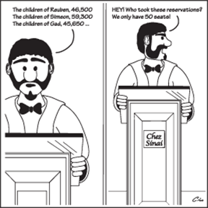

APRIL 2021
Deacon of the Week MW Nursery Children’s Worship

April 4 Stephen Spicer None Family Sunday

April 11 Chris Beverly None Rita Fields/Angie A.

April 18 Doug Gross None Rita Fields/Angie A.

April 25 Mickey Hall None Rita Fields/Angie A.

Sunday Monday Tuesday Wednesday Thursday Friday Saturday
SUN MON TUE WED THUR FRI SAT
ABY FALL RETREAT at Camp Camby, November 7th-9th
VACATION BIBLE SCHOOL NIGHTLY BEGINNING WITH A MEAL AT 5:30 PM & ENDING AT 8:30 PM.
Kindergarten Camp 3 PM Sun.-4 PM Mon.

Women’s Conference at KCBC for all women of the church & the community. Led by Jenny Beverly.
2012

21

5:00 PM Friday thru 4:00 PM on Saturday

