 |  | 1 | 2 | 3 | 4 | 5  Youth Bell Ringing at  Wal-Mart  10 a.m.-12 p.m.
6 Communion  Deacon’s Mtg, 12p  Carols & Choirs at Kimberlin Creek 6:00 PM  chi | 7 | 8 | 9  Business Mtg. 6:30 | 10 | 11  Outing to see the Charlestown Christmas Lights  6:00 PM | 12
13 | 14 | 15 January | 16 | 17 | 18 5:30-8 PM | 19  Youth Bell Ringing at Wal-Mart  10 a.m.-12 p.m.  “Shared Blessings” 10a.m.-2pm
20  10:30 a.m. | 21 | 22 | 23 | 24 11 PM |  | 26
27  FLC in use (Blevins Family, 1-4 PM)  Movie Night at the church, 5 PM  “The Santa Clause” | 28  Youth outing to The Creation Museum – leave church at noon | 29 | 30 | 31  Youth Lock-in at the church, 6PM Thursday - 9 a.m. Friday |  | The Parks family may be using the FLC on Christmas Day at 4:00 PM.

December 2020
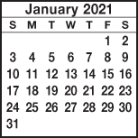
Deacon of the Week MW Nursery Children’s Worship

Dec. 6 Doug Gross Family Sunday

Dec. 13 Jeff Riley Rita Fields

Dec. 20 Stephen Spicer Christmas Cantata

Dec. 27 Chris Beverly Rita Fields

KIMBERLIN CREEK BAPTIST CHURCH
Regular Weekly Schedule

Sunday 9:30 a.m. Sunday School
10:30 a.m. Morning Worship Tuesday 6:30 p.m. Choir Practice
Thursday 7 p.m. Zoom Bible Study

Sunday School Greeters

Morning Worship Greeters

*******************************
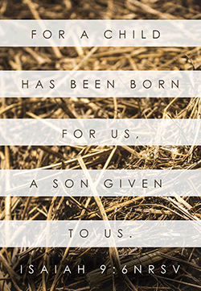

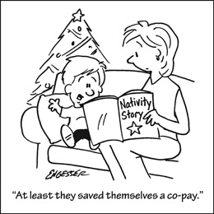

Sunday Monday Tuesday Wednesday Thursday Friday Saturday
SUN MON TUE WED THUR FRI SAT
ABY FALL RETREAT at Camp Camby, November 7th-9th
VACATION BIBLE SCHOOL NIGHTLY BEGINNING WITH A MEAL AT 5:30 PM & ENDING AT 8:30 PM.
Kindergarten Camp 3 PM Sun.-4 PM Mon.

Women’s Conference at KCBC for all women of the church & the community. Led by Jenny Beverly.
2012

21

5:00 PM Friday thru 4:00 PM on Saturday

