 | 1  1-7 Pastor Tim will be on vacation | 2 | 3 | 4  CCA ABMen’s Quarterly Mtg. at Alpha Baptist,  7:00 PM | 5 | 6  FLC in use the Braden Family  most all day
7 Communion  Deacon’s Mtg. 12  chi | 8 | 9 | 10  Business Mtg. 6:30 | 11  Youth Volunteering at the Clearinghouse  9 a.m.-12 PM | 12 | 13  Youth Lock-in at KCBC, 5:00 PM
14  Youth Sunday  Graduation Sunday | 15 | 16  Red Cross Blood Drive in FLC  3:00-8:00 PM | 17 | 18  Youth Volunteering at the Clearinghouse  9 a.m.-12 PM | 19-20  Lexington Old Settlers’ at the Ball Park | 20  VBS Float in Parade, 11 a.m.  “Shared Blessings” 10a.m.-2pm
21  Community Service at the Lexington Ball Park, 10:00 a.m.  Float in Fair Parade  3:00 PM | 22 | 23 JULY | 24 | 25 | 26 | 27
28  FLC in use, 1-4  David Wells  CCA Executive Bd Mtg., 2 PM, KCBC | 29 | 30
JUNE 2020
Deacon of the Week MW Nursery Children’s Worship

June 7 Stephen Spicer Need Volunteers Family Sunday

June 14 Chris Beverly Need Volunteers None

June 21 Doug Gross No Services at the church No Services at the church

June 28 Mickey Hall Need Volunteers None
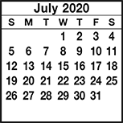
KIMBERLIN CREEK BAPTIST CHURCH
Regular Weekly Schedule

Sunday 9:30 a.m. Sunday School
10:30 a.m. Morning Worship
Wednesday
5:30 p.m. Family Meal
6:30 p.m. Bible Study
TeamKid
Youth Meeting

Sunday School Greeters

June 7 Jim & Hazel West
June 14 Jason Sebastian
June 21 none today
June 28 Chris Beverly
Morning Worship Greeters

June 7 Kay McCrady/Dixie Miller
June 14 Carell & Barbara Braden
June 21 Community Service
June 28 Barb Deal/Dorothy Gray
*******************************
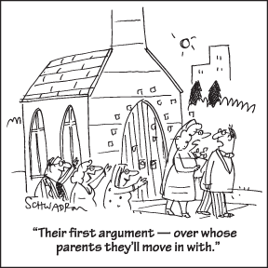

Sunday Monday Tuesday Wednesday Thursday Friday Saturday
SUN MON TUE WED THUR FRI SAT
ABY FALL RETREAT at Camp Camby, November 7th-9th
VACATION BIBLE SCHOOL NIGHTLY BEGINNING WITH A MEAL AT 5:30 PM & ENDING AT 8:30 PM.
Kindergarten Camp 3 PM Sun.-4 PM Mon.

Women’s Conference at KCBC for all women of the church & the community. Led by Jenny Beverly.
2012

21

5:00 PM Friday thru 4:00 PM on Saturday

