 |  |  |  |  | 1 | 2
3 Communion  Deacon’s Mtg. 12  chi | 4 | 5 | 6 | 7  CCA ABMen;s Quarterly Mtg. at Alpha Baptist  7:00 PM | 8 | 9  CANCELLED
10 | 11 | 12 | 13  Business Mtg.  6:30 PM | 14 | 15  Family Game Night, 6 PM | 16  Shared Blessings  10 a.m.- 2 PM
17  CCA Spring Singspiration at KCBC, 6 PM | 18 | 19 June | 20 | 21 | 22 | 23
24 FLC in use, 2-4  Karen Middleton  31”Share the Love” Hwy. 356 Cleanup, 12 | 25 | 26 | 27 | 28 | 29 | 30  Bobby & Barb Deal’s 50th Wedding Anniversary Celebration in FLC.  Time: TBA
Lexington Revival Services behind LeRoy’s, 7:00 PM nightly (CANCELLED)
Before you attempt to go to any event or activity, please check your email, text messages or Facebook to see if it is still on.

MAY 2020
Deacon of the Week MW Nursery Children’s Worship

May 3 Stephen Spicer Volunteers needed Family Sunday

May 10 Chris Beverly Volunteers needed Mother’s Day

May 17 Doug Gross Volunteers needed none

May 24 Mickey Hall Volunteers needed none

May 31 Jeff Riley Volunteers needed none

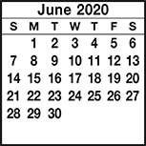
KIMBERLIN CREEK BAPTIST CHURCH
Regular Weekly Schedule

Sunday 9:30 a.m. Sunday School
10:30 a.m. Morning Worship
Wednesday
5:30 p.m. Family Meal
6:30 p.m. Bible Study
TeamKid
Youth Meeting

Sunday School Greeters

May 3 Beulah Wells
May 10 Jim & Hazel West
May 17 Jason Sebastian
May 24 Chris Beverly
May 31 Beulah Wells
Morning Worship Greeters

May 3 Carell & Barbara Braden
May 10 Barb Deal/Dorothy Gray
May 17 Rita Fields/Angie Avendano
May 24 JoAn Azure/Jason Sebastian
May 31 Larry & Marcia Blevins
*******************************
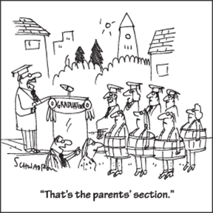

Sunday Monday Tuesday Wednesday Thursday Friday Saturday
SUN MON TUE WED THUR FRI SAT
ABY FALL RETREAT at Camp Camby, November 7th-9th
VACATION BIBLE SCHOOL NIGHTLY BEGINNING WITH A MEAL AT 5:30 PM & ENDING AT 8:30 PM.
Kindergarten Camp 3 PM Sun.-4 PM Mon.

Women’s Conference at KCBC for all women of the church & the community. Led by Jenny Beverly.
2012

21

5:00 PM Friday thru 4:00 PM on Saturday

